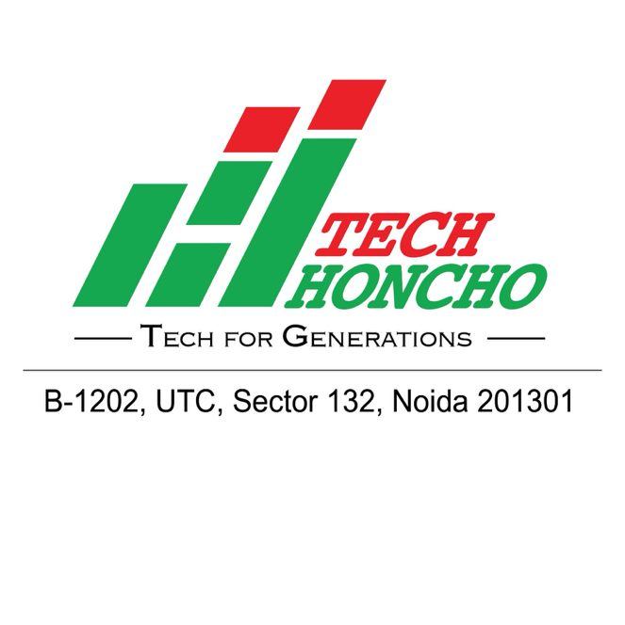

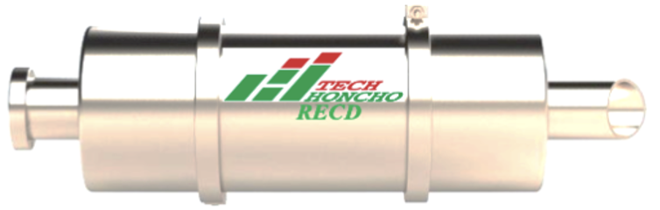



**SMART SOLUTION FOR EMISSION CONTROL**



VISION

MISSION







Retrofit Emission Control Device (RECD)

**Introduction**

The pressing issue of rising levels of air pollution has become a grave concern that continues to have far-reaching consequences on the environment and significant health risks, particularly in developing nations. The impact of air pollution cannot be underestimated. Its adverse effects on the ozone layer and public health are alarming, demanding our immediate consideration and united efforts.

In response to this alarming situation, the Ministry of Environment, Forest and Climate Change, Government of India, released the National Clean Air Programme (NCAP) on 31st December 2018, while the National Green Tribunal mandated the use of Retrofit Emission Control Device (RECD) for reducing Air Pollution from Diesel Generators, as per their Order O.A. No. 681/2018 dated 6th August 2019.

Recognizing the urgent need for a solution, TEC HONCO TECHNOLOGIES PVT LTD, a renowned manufacturer has introduced an effective remedy – the Retrofit Emission Control Device (RECD) designed for Diesel Generators ranging from 125 kVA to 1000 kVA. Our RECD stands out as an innovative technology capable of significantly reducing exhaust emissions. Through Oxidation and Passive Regenerative Trap principles, it achieves an impressive 70% to 90% reduction in Diesel Particulate Matter (DPM) emissions, and a minimum of 70% reduction in other harmful pollutants like Hydrocarbons & Carbon Monoxide.

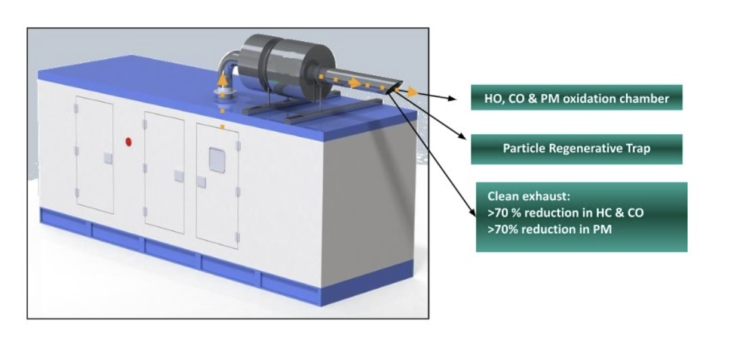

Moreover, the TEC HONCO RECD aligns perfectly with the guidelines set forth by the National Green Tribunal, boasting a reduction efficiency of over 70% for Particulate Matter (PM), Carbon Monoxide (CO), and Hydrocarbons (HC). This accomplishment has been validated by CPCB accredited labs, ensuring compliance with stringent emission standards.

The TEC HONCO RECD boasts an impressive lifespan of 10 to 12 years or 40,000 hours, promising reliable performance and longevity. It also maintains noise levels well within permissible CPCB limits, while requiring low maintenance, only once every 6 months or 500 hours. Furthermore, our RECD has been thoughtfully designed to prevent adverse effects on the engine by maintaining low back pressure within permissible limits. Its compact size eliminates the need for additional floor space, making it a highly convenient and space-efficient solution.

**Operating Principle**

**Technology comparisons and advantages:** ∙ RECD is installed after the diesel genset muffler without disturbing the existing setup ∙ Exhaust gases enter RECD and are confronted with electrical discharge created through high voltage DC field ∙ Passing through the field, particulate matter acquires electrical charge and is attracted to the oppositely charged electrode ∙ PM gets agglomerated on the collector electrode and forms substantially higher particle-size clusters ∙ Agglomerated PM is periodically scrapped and collected using a patented mechanism for environmentally safe disposal∙ Robust component build with stringent quality requirements ∙ Genset-like bedframe-based installation, protection from environmental factors such as heat-resistant paint on internal units, galvanized and powder-coated sheets and structural members for enclosure, thermal management for power and control unit, well-designed seals and interfaces Installation aspects: ∙ Installation checklist as well as pre-order site survey for feasibility (for larger independent installations)

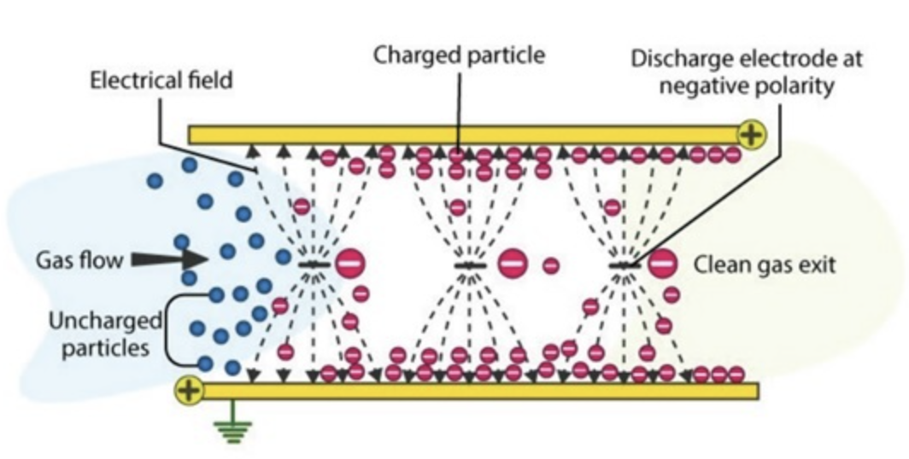

Technical Specifications (Indicative)

|  |  |
| --- | --- |
| Parameter | Specification |
| Efficiency | Up to **80-90% reduction** in PM and NOx |
| Compatibility | DG Sets **125 kVA & above** |
| Filtration Technology | DPF, SCR, ESP, or Hybrid Systems |
| Pressure Drop | ≤ 50 mm WC |
| Noise Level | ≤ 75 dB (as per CPCB norms) |
| Lifespan | 5+ Years |
| Compliance Standards | **CPCB-IV+, NGT, MoEFCC Guidelines** |

Our Offered RECD Benefits

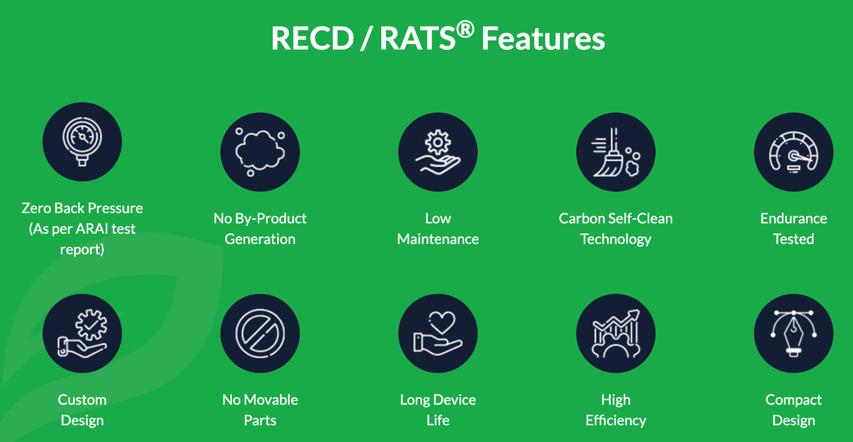

✔ **Up to 80-90% reduction** in PM & NOx emissions  
✔ **Compliance with CPCB & NGT guidelines**  
✔ **Improved fuel efficiency** & reduced maintenance costs  
✔ **Eco-friendly solution** for industrial and commercial operations  
✔ **Eligibility for carbon credits & green certifications**

RECD Range Based on DG Set Capacities

|  |  |  |  |
| --- | --- | --- | --- |
| DG Set Capacity (kVA) | RECD Technology | Emission Reduction Efficiency | Compliance Standard |
| 25 – 75 kVA | Diesel Particulate Filter (DPF), Catalytic Converter | **60-80% PM reduction** | CPCB-IV+ / NGT |
| 100 – 250 kVA | Diesel Particulate Filter (DPF) + Selective Catalytic Reduction (SCR) | **70-90% PM & NOx reduction** | CPCB-IV+, NGT |
| 300 – 500 kVA | SCR + Diesel Oxidation Catalyst (DOC) | **80-90% reduction** | CPCB-IV+, NGT |
| 625 – 1000 kVA | Hybrid System (DPF + SCR + Electrostatic Precipitator) | **90%+ reduction** | CPCB-IV+, NGT |
| 1250 – 2000+ kVA | High-Capacity SCR + Ammonia Injection System | **90%+ reduction** | CPCB-IV+, MoEFCC |

Government Regulations & Compliance

📌 **CPCB Notification (2020)** – Mandatory for DG sets **≥125 kVA**  
📌 **NGT Orders (2021 & 2023)** – RECD required in **NCR, major cities & industrial areas**  
📌 **State Pollution Control Board (SPCB) Guidelines** – Local enforcement of emission norms

